**Project Report Template**

**UNCOVERING GAMING INDUSTRIES’ HIDDEN GEMS :**

**A COMPREHENSIVE ANALYSIS OF VIDEO GAME SALES**

1. **INTRODUCTION**

Videogames are very common today but not long ago they were played on large and bulky personal computing systems. Now they’re available for download on laptops, mobile phones and dedicated gaming consoles. The Indian gaming industry is set to be worth $1.1 bn in 2020 with a projected 628 million online gamers. This rise in popularity is largely due to the increased accessibility of the public to video games as well as multi-platform dissemination along with a saturated and affordable technology market ensures that smart devices reach even larger sections of society every year. The internet penetration in India is expected to reach 53% of its population by 2021.

* 1. **Overview**

The project is done keeping in mind the interest of those who wish to play online games of different genre and to kindle the interest of those who aspire to play games. Another aspect of this project is to present the data of those playing online games and those who provide platform to play games using simple computer programme.

**1.2 Purpose**

The use of this project is to explain how many publishers their release their game in their our platform in the gaming genre. This project is used to identify data pertaining to those who are intersected in playing online games. It helps to identify the network data using the mySQL.

**2 Problem Definition & Design Thinking**

**2.1 Empathy Map**

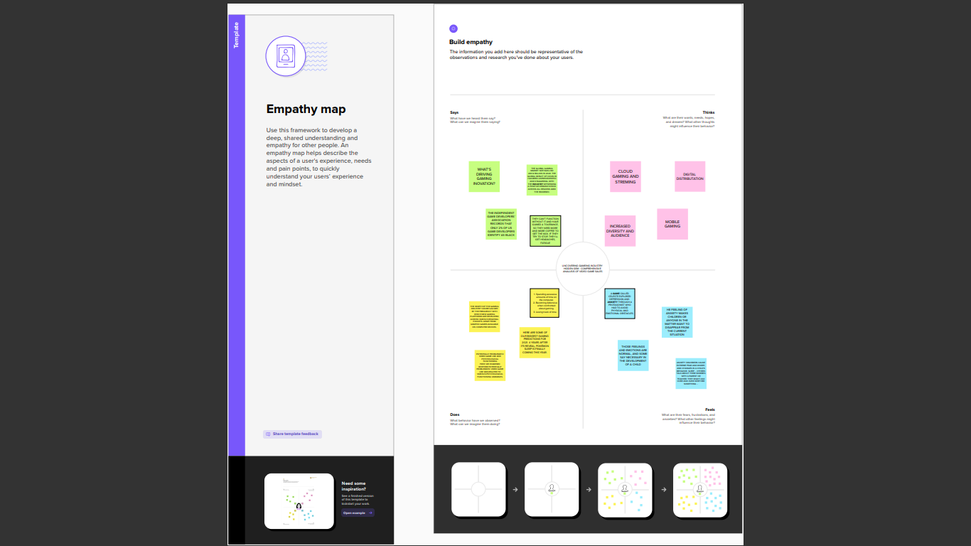

**2.2 Ideation & Brainstorming Map**

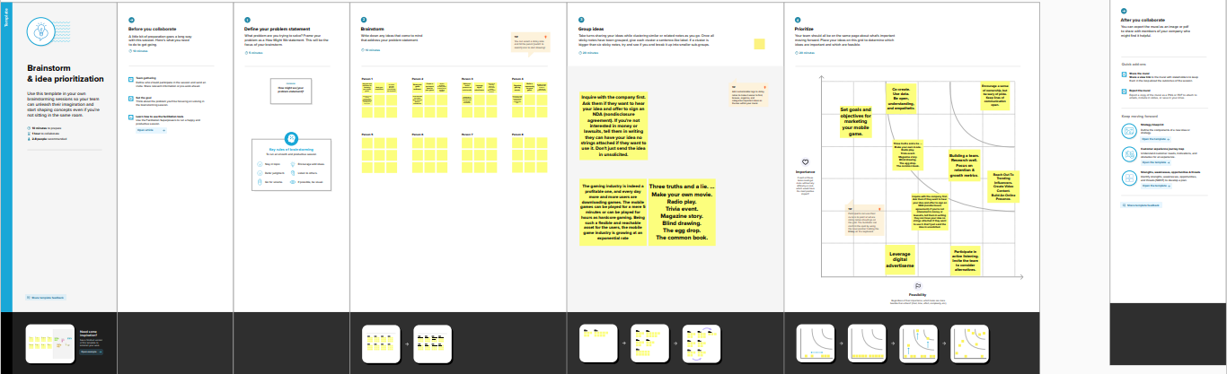

**3. RESULT**

**1.Dashboard & Story of the uncovering games of industries**

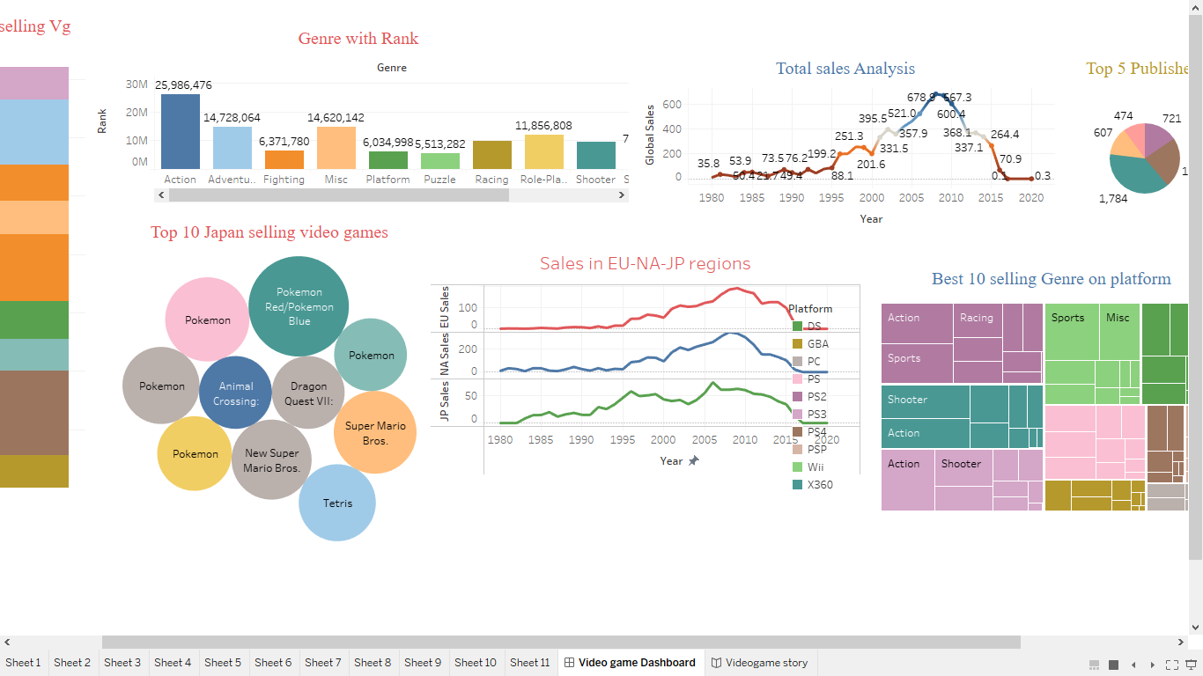

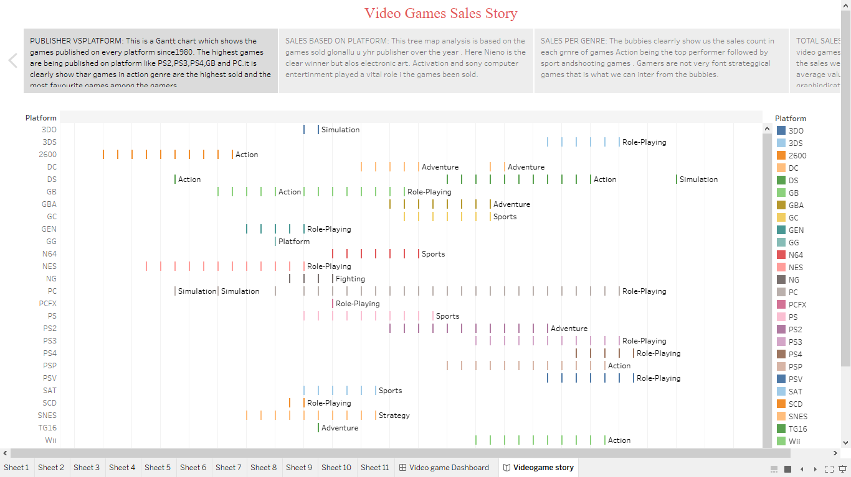

**4 ADVANTAGES & DISADVANTAGES**

|  |  |
| --- | --- |
| **ADVANTAGES** | **DIS-ADVANTAGES** |
| Improved cognitive functions | Physical Health Issue Spending several hours playing online video games results in poor physical health. |
| Problem-solving skills and the use of logic | Insomnia Another negative effect of video games is that video gamers are expected to have difficulty sleeping |
| Hand-to-eye coordination | Lack of Concentration |
| Improved eye for details | Poor Academic Performance. |
| Faster and more accurate decision-making | Lead to Social Isolation. |

**5 APPLICATIONS**

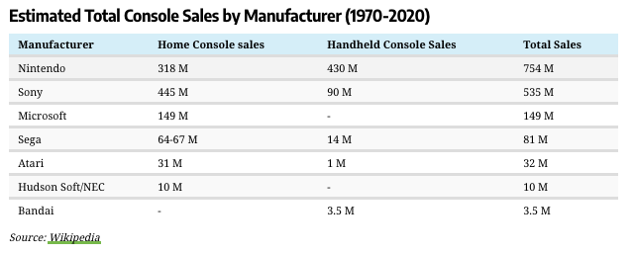

**6 CONCLUSION**

In our project we see that uncovering gaming industry. We see that what are the profit gaining global wise. There are 16,000 data are collected

Video games are a form of media that is often associated with negative health consequences. However, when games are played in moderation and with mindfulness, they are a viable source of stress relief as well as a catalyst for mental health improvement and development of social skills. Video games themselves are a relatively modern form of entertainment. They are engaging and immersive on a level different from that of traditional board games and other forms of entertainment. The player actively contributes to the level of satisfaction he/she attains from this medium and thus is more  invested and willing to engage in the elements of the video game. The amount of play time is also an important factor in the effects of gaming. Although excessive playtime can have negative consequence, gaming in moderation can be healthy, fun, and educational.

**7 FUTURE SCOPE**

The gaming industry has an array of career choices to offer. It makes up for a large segment on the employment front too. According to statistics shared by the American Gaming Association, game industry jobs provide employment to as many as 1.7 million individuals, with the employment rate growing by 62,000 jobs (on average) every year.

The most common myth about **game industry jobs** is the lack of options. However, game careers are not limited to game design and game development. Here are some game industry jobs that you can take up as a profession:

* **Video Game Designer:**

you don’t code and cannot sketch, but you have a million-dollar idea for a game that could be a breakthrough. Well, you are not in for a disappointment. The job of a video game designer is to create a blueprint of the characters and the purpose of the game.

**8 APPENDIX**

1. **Source Code**
2. <!DOCTYPE html>
3. <html lang="en">
4. <head>
5. <meta charset="utf-8">
6. <meta content="width=device-width, initial-scale=1.0" name="viewport">
7. <title>Video Games Sales Analysis</title>
8. <meta content="" name="description">
9. <meta content="" name="keywords">
10. <!-- Favicons -->
11. <link href="assets/img/favicon.png" rel="icon">
12. <link href="assets/img/apple-touch-icon.png" rel="apple-touch-icon">
13. <!-- Google Fonts -->
14. <link href="https://fonts.googleapis.com/css?family=Open+Sans:300,300i,400,400i,600,600i,700,700i|Raleway:300,300i,400,400i,500,500i,600,600i,700,700i|Poppins:300,300i,400,400i,500,500i,600,600i,700,700i" rel="stylesheet">
15. <!-- Vendor CSS Files -->
16. <link href="assets/vendor/aos/aos.css" rel="stylesheet">
17. <link href="assets/vendor/bootstrap/css/bootstrap.min.css" rel="stylesheet">
18. <link href="assets/vendor/bootstrap-icons/bootstrap-icons.css" rel="stylesheet">
19. <link href="assets/vendor/boxicons/css/boxicons.min.css" rel="stylesheet">
20. <link href="assets/vendor/glightbox/css/glightbox.min.css" rel="stylesheet">
21. <link href="assets/vendor/remixicon/remixicon.css" rel="stylesheet">
22. <link href="assets/vendor/swiper/swiper-bundle.min.css" rel="stylesheet">
23. <!-- Template Main CSS File -->
24. <link href="assets/css/style.css" rel="stylesheet">
25. <!-- =======================================================
26. * Template Name: Presento - v3.9.1
27. * Template URL: https://bootstrapmade.com/presento-bootstrap-corporate-template/
28. * Author: BootstrapMade.com
29. * License: https://bootstrapmade.com/license/
30. ======================================================== -->
31. </head>
32. <body>
33. <!-- ======= Header ======= -->
34. <header id="header" class="fixed-top d-flex align-items-center">
35. <div class="container d-flex align-items-center">
37. <h3 class="logo me-auto"><a href="index.html">VIDEO GAMES SALES ANALYSIS<span>.</span></a></h3>
38. <!-- Uncomment below if you prefer to use an image logo -->
39. <!-- <a href="index.html" class="logo me-auto"><img src="assets/img/logo.png" alt=""></a>-->
40. <nav id="navbar" class="navbar order-last order-lg-0">
41. <ul>
42. <li><a class="nav-link scrollto active" href="#hero">Home</a></li>
43. <li><a class="nav-link scrollto" href="#about">Prologue</a></li>
44. <li><a class="nav-link scrollto" href="#services">Challenge</a></li>
45. <li><a class="nav-link scrollto " href="#portfolio">Charts</a></li>
46. <li><a class="nav-link scrollto" href="#team">Dashboard</a></li>
47. <li><a class="nav-link scrollto" href="#Story">Story</a></li>
48. <li><a class="nav-link scrollto" href="#Report">Conclusion</a></li>
50. <!--  <li class="dropdown"><a href="#"><span>Drop Down</span> <i class="bi bi-chevron-down"></i></a>
51. <ul>
52. <li><a href="#">Drop Down 1</a></li>
53. <li class="dropdown"><a href="#"><span>Deep Drop Down</span> <i class="bi bi-chevron-right"></i></a>
54. <ul>
55. <li><a href="#">Deep Drop Down 1</a></li>
56. <li><a href="#">Deep Drop Down 2</a></li>
57. <li><a href="#">Deep Drop Down 3</a></li>
58. <li><a href="#">Deep Drop Down 4</a></li>
59. <li><a href="#">Deep Drop Down 5</a></li>
60. </ul>
61. </li>
62. <li><a href="#">Drop Down 2</a></li>
63. <li><a href="#">Drop Down 3</a></li>
64. <li><a href="#">Drop Down 4</a></li>
65. </ul>
66. </li>
67. <li><a class="nav-link scrollto" href="#contact">Contact</a></li>
68. </ul>
69. <i class="bi bi-list mobile-nav-toggle"></i>
70. </nav> .navbar -->
72. </div>
73. </header><!-- End Header -->
74. <!-- ======= Hero Section ======= -->
75. <section id="hero" class="d-flex align-items-center">
76. <div class="container" data-aos="zoom-out" data-aos-delay="100">
77. <div class="row">
78. <div class="col-xl-6">
79. <h1>A Tableau Presentation</h1>
80. <a href="#about" class="btn-get-started scrollto">Get Started</a>
81. </div>
82. </div>
83. </div>
84. </section><!-- End Hero -->
85. <main id="main">
86. <!-- ======= Clients Section =======
87. <section id="clients" class="clients">
88. <div class="container" data-aos="zoom-in">
89. <div class="clients-slider swiper">
90. <div class="swiper-wrapper align-items-center">
91. <div class="swiper-slide"><img src="assets/img/clients/client-1.png" class="img-fluid" alt=""></div>
92. <div class="swiper-slide"><img src="assets/img/clients/client-2.png" class="img-fluid" alt=""></div>
93. <div class="swiper-slide"><img src="assets/img/clients/client-3.png" class="img-fluid" alt=""></div>
94. <div class="swiper-slide"><img src="assets/img/clients/client-4.png" class="img-fluid" alt=""></div>
95. <div class="swiper-slide"><img src="assets/img/clients/client-5.png" class="img-fluid" alt=""></div>
96. <div class="swiper-slide"><img src="assets/img/clients/client-6.png" class="img-fluid" alt=""></div>
97. <div class="swiper-slide"><img src="assets/img/clients/client-7.png" class="img-fluid" alt=""></div>
98. <div class="swiper-slide"><img src="assets/img/clients/client-8.png" class="img-fluid" alt=""></div>
99. </div>
100. <div class="swiper-pagination"></div>
101. </div>
102. </div>
103. </section><!-- End Clients Section -->
104. <!-- ======= About Section ======= -->
105. <section id="about" class="about section-bg">
106. <div class="container" data-aos="fade-up">
107. <div class="row no-gutters">
108. <div class="content col-xl-5 d-flex align-items-stretch">
109. <div class="content">
111. <p>
112. Video Games since it's inception has touched many souls by their augmented reality and graphics,apart from being a good to boredom it also shows us the way technology has been developed from single Ninendo to PS5, from road rash to God of war.
113. </p>
114. <p>This project is a complete analysis of video games sold since 1980.It consist of video games with their publisher and platform with the genre of games on which year they were published with the sales they made in North America,Japan,Europe and other regions.
115. </p>
116. </div>
117. </div>
118. <div class="col-xl-7 d-flex align-items-stretch">
119. <div class="icon-boxes d-flex flex-column justify-content-center">
120. <div class="row">
121. <div class="col-md-6 icon-box" data-aos="fade-up" data-aos-delay="100">
122. <!--  <i class="bx bx-receipt"></i>
123. <h4>Super Mario Bros</h4>
124. <p>Super Mario Bros is a platform game developed and published by Nintendo for the Nintendo Entertainment System(NES).</p>
125. </div>
126. <div class="col-md-6 icon-box" data-aos="fade-up" data-aos-delay="200">
127. <i class="bx bx-cube-alt"></i>
128. <h4>Wii Sports</h4>
129. <p>Wii Sports is a 2006 sports simulation video game developed and published by Nintendo for the Wii video game console.</p>
130. </div>
131. <div class="col-md-6 icon-box" data-aos="fade-up" data-aos-delay="300">
132. <i class="bx bx-images"></i>
133. <h4>Labore consequatur</h4>
134. <p>ut suscipit aut cum nemo deleniti aut omnis. Doloribus ut maiores omnis facere</p>
135. </div>
136. <div class="col-md-6 icon-box" data-aos="fade-up" data-aos-delay="400">
137. <i class="bx bx-shield"></i>
138. <h4>Beatae veritatis</h4>
139. <p>Expedita veritatis consequuntur nihil tempore laudantium vitae denat pacta</p>
140. </div>
141. </div>
142. </div>End .content
143. </div>End .content
144. </div>
145. </div>End .content-->
146. </section><!-- End About Section -->
147. <!-- ======= Counts Section ======= -->
148. <!--<section id="counts" class="counts">
149. <div class="container" data-aos="fade-up">
150. <div class="row">
151. <div class="col-lg-3 col-md-6">
152. <div class="count-box">
153. <i class="bi bi-emoji-smile"></i>
154. <span data-purecounter-start="0" data-purecounter-end="232" data-purecounter-duration="1" class="purecounter"></span>
155. <p>Happy Clients</p>
156. </div>
157. </div>
158. <div class="col-lg-3 col-md-6 mt-5 mt-md-0">
159. <div class="count-box">
160. <i class="bi bi-journal-richtext"></i>
161. <span data-purecounter-start="0" data-purecounter-end="521" data-purecounter-duration="1" class="purecounter"></span>
162. <p>Projects</p>
163. </div>
164. </div>
165. <div class="col-lg-3 col-md-6 mt-5 mt-lg-0">
166. <div class="count-box">
167. <i class="bi bi-headset"></i>
168. <span data-purecounter-start="0" data-purecounter-end="1463" data-purecounter-duration="1" class="purecounter"></span>
169. <p>Hours Of Support</p>
170. </div>
171. </div>
172. <div class="col-lg-3 col-md-6 mt-5 mt-lg-0">
173. <div class="count-box">
174. <i class="bi bi-people"></i>
175. <span data-purecounter-start="0" data-purecounter-end="15" data-purecounter-duration="1" class="purecounter"></span>
176. <p>Hard Workers</p>
177. </div>
178. </div>
179. </div>
180. </div>
181. </section> End Counts Section -->
182. <!-- ======= Tabs Section ======= -->
183. <!--<section id="tabs" class="tabs">
184. <div class="container" data-aos="fade-up">
185. <ul class="nav nav-tabs row d-flex">
186. <li class="nav-item col-3">
187. <a class="nav-link active show" data-bs-toggle="tab" data-bs-target="#tab-1">
188. <i class="ri-gps-line"></i>
189. <h4 class="d-none d-lg-block">Modi sit est dela pireda nest</h4>
190. </a>
191. </li>
192. <li class="nav-item col-3">
193. <a class="nav-link" data-bs-toggle="tab" data-bs-target="#tab-2">
194. <i class="ri-body-scan-line"></i>
195. <h4 class="d-none d-lg-block">Unde praesenti mara setra le</h4>
196. </a>
197. </li>
198. <li class="nav-item col-3">
199. <a class="nav-link" data-bs-toggle="tab" data-bs-target="#tab-3">
200. <i class="ri-sun-line"></i>
201. <h4 class="d-none d-lg-block">Pariatur explica nitro dela</h4>
202. </a>
203. </li>
204. <li class="nav-item col-3">
205. <a class="nav-link" data-bs-toggle="tab" data-bs-target="#tab-4">
206. <i class="ri-store-line"></i>
207. <h4 class="d-none d-lg-block">Nostrum qui dile node</h4>
208. </a>
209. </li>
210. </ul>
211. <div class="tab-content">
212. <div class="tab-pane active show" id="tab-1">
213. <div class="row">
214. <div class="col-lg-6 order-2 order-lg-1 mt-3 mt-lg-0" data-aos="fade-up" data-aos-delay="100">
215. <h3>Voluptatem dignissimos provident quasi corporis voluptates sit assumenda.</h3>
216. <p class="fst-italic">
217. Lorem ipsum dolor sit amet, consectetur adipiscing elit, sed do eiusmod tempor incididunt ut labore et dolore
218. magna aliqua.
219. </p>
220. <ul>
221. <li><i class="ri-check-double-line"></i> Ullamco laboris nisi ut aliquip ex ea commodo consequat.</li>
222. <li><i class="ri-check-double-line"></i> Duis aute irure dolor in reprehenderit in voluptate velit.</li>
223. <li><i class="ri-check-double-line"></i> Ullamco laboris nisi ut aliquip ex ea commodo consequat. Duis aute irure dolor in reprehenderit in voluptate trideta storacalaperda mastiro dolore eu fugiat nulla pariatur.</li>
224. </ul>
225. <p>
226. Ullamco laboris nisi ut aliquip ex ea commodo consequat. Duis aute irure dolor in reprehenderit in voluptate
227. velit esse cillum dolore eu fugiat nulla pariatur. Excepteur sint occaecat cupidatat non proident, sunt in
228. culpa qui officia deserunt mollit anim id est laborum
229. </p>
230. </div>
231. <div class="col-lg-6 order-1 order-lg-2 text-center" data-aos="fade-up" data-aos-delay="200">
232. <img src="assets/img/tabs-1.jpg" alt="" class="img-fluid">
233. </div>
234. </div>
235. </div>
236. <div class="tab-pane" id="tab-2">
237. <div class="row">
238. <div class="col-lg-6 order-2 order-lg-1 mt-3 mt-lg-0">
239. <h3>Neque exercitationem debitis soluta quos debitis quo mollitia officia est</h3>
240. <p>
241. Ullamco laboris nisi ut aliquip ex ea commodo consequat. Duis aute irure dolor in reprehenderit in voluptate
242. velit esse cillum dolore eu fugiat nulla pariatur. Excepteur sint occaecat cupidatat non proident, sunt in
243. culpa qui officia deserunt mollit anim id est laborum
244. </p>
245. <p class="fst-italic">
246. Lorem ipsum dolor sit amet, consectetur adipiscing elit, sed do eiusmod tempor incididunt ut labore et dolore
247. magna aliqua.
248. </p>
249. <ul>
250. <li><i class="ri-check-double-line"></i> Ullamco laboris nisi ut aliquip ex ea commodo consequat.</li>
251. <li><i class="ri-check-double-line"></i> Duis aute irure dolor in reprehenderit in voluptate velit.</li>
252. <li><i class="ri-check-double-line"></i> Provident mollitia neque rerum asperiores dolores quos qui a. Ipsum neque dolor voluptate nisi sed.</li>
253. <li><i class="ri-check-double-line"></i> Ullamco laboris nisi ut aliquip ex ea commodo consequat. Duis aute irure dolor in reprehenderit in voluptate trideta storacalaperda mastiro dolore eu fugiat nulla pariatur.</li>
254. </ul>
255. </div>
256. <div class="col-lg-6 order-1 order-lg-2 text-center">
257. <img src="" alt="" class="img-fluid">
258. </div>
259. </div>
260. </div>
261. <div class="tab-pane" id="tab-3">
262. <div class="row">
263. <div class="col-lg-6 order-2 order-lg-1 mt-3 mt-lg-0">
264. <h3>Voluptatibus commodi ut accusamus ea repudiandae ut autem dolor ut assumenda</h3>
265. <p>
266. Ullamco laboris nisi ut aliquip ex ea commodo consequat. Duis aute irure dolor in reprehenderit in voluptate
267. velit esse cillum dolore eu fugiat nulla pariatur. Excepteur sint occaecat cupidatat non proident, sunt in
268. culpa qui officia deserunt mollit anim id est laborum
269. </p>
270. <ul>
271. <li><i class="ri-check-double-line"></i> Ullamco laboris nisi ut aliquip ex ea commodo consequat.</li>
272. <li><i class="ri-check-double-line"></i> Duis aute irure dolor in reprehenderit in voluptate velit.</li>
273. <li><i class="ri-check-double-line"></i> Provident mollitia neque rerum asperiores dolores quos qui a. Ipsum neque dolor voluptate nisi sed.</li>
274. </ul>
275. <p class="fst-italic">
276. Lorem ipsum dolor sit amet, consectetur adipiscing elit, sed do eiusmod tempor incididunt ut labore et dolore
277. magna aliqua.
278. </p>
279. </div>
280. <div class="col-lg-6 order-1 order-lg-2 text-center">
281. <img src="assets/img/tabs-3.jpg" alt="" class="img-fluid">
282. </div>
283. </div>
284. </div>
285. <div class="tab-pane" id="tab-4">
286. <div class="row">
287. <div class="col-lg-6 order-2 order-lg-1 mt-3 mt-lg-0">
288. <h3>Omnis fugiat ea explicabo sunt dolorum asperiores sequi inventore rerum</h3>
289. <p>
290. Ullamco laboris nisi ut aliquip ex ea commodo consequat. Duis aute irure dolor in reprehenderit in voluptate
291. velit esse cillum dolore eu fugiat nulla pariatur. Excepteur sint occaecat cupidatat non proident, sunt in
292. culpa qui officia deserunt mollit anim id est laborum
293. </p>
294. <p class="fst-italic">
295. Lorem ipsum dolor sit amet, consectetur adipiscing elit, sed do eiusmod tempor incididunt ut labore et dolore
296. magna aliqua.
297. </p>
298. <ul>
299. <li><i class="ri-check-double-line"></i> Ullamco laboris nisi ut aliquip ex ea commodo consequat.</li>
300. <li><i class="ri-check-double-line"></i> Duis aute irure dolor in reprehenderit in voluptate velit.</li>
301. <li><i class="ri-check-double-line"></i> Ullamco laboris nisi ut aliquip ex ea commodo consequat. Duis aute irure dolor in reprehenderit in voluptate trideta storacalaperda mastiro dolore eu fugiat nulla pariatur.</li>
302. </ul>
303. </div>
304. <div class="col-lg-6 order-1 order-lg-2 text-center">
305. <img src="assets/img/tabs-4.jpg" alt="" class="img-fluid">
306. </div>
307. </div>
308. </div>
309. </div>
310. </div>
311. </section>End Tabs Section -->
312. <!-- ======= Services Section ======= -->
313. <section id="services" class="services section-bg ">
314. <div class="container" data-aos="fade-up">
315. <div class="section-title">
316. <h2>Challenges</h2>
317. <p>Analysing sales data from more than 16,500 games.This dataset contains a list of video games with sales greater than 100,000 copies. It was generated by a scrape of vgchartz.com.</p>
318. <p>Let us check some top sale video games</p>
319. </div>
321. <div class="row">
322. <div class="col-md-6">
323. <div class="icon-box" data-aos="fade-up" data-aos-delay="100">
324. <!-- <i class="bi bi-briefcase"></i> -->
325. <h4><a href="#">Super Mario Bros</a></h4>
326. <p>Super Mario Bros is a platform game developed and published by Nintendo for the Nintendo Entertainment System(NES).</p>
327. </div>
328. </div>
329. <div class="col-md-6 mt-4 mt-md-0">
330. <div class="icon-box" data-aos="fade-up" data-aos-delay="200">
331. <!-- <i class="bi bi-card-checklist"></i> -->
332. <h4><a href="#">Wii Sports</a></h4>
333. <p>Wii Sports is a 2006 sports simulation video game developed and published by Nintendo for the Wii video game console.</p>
334. </div>
335. </div>
336. <div class="col-md-6 mt-4 mt-md-0">
337. <div class="icon-box" data-aos="fade-up" data-aos-delay="300">
338. <!-- <i class="bi bi-bar-chart"></i> -->
339. <h4><a href="#">Pokemon Red/Pokemon Blue</a></h4>
340. <p>Pokémon Red Version and Pokémon Blue Version are 1996 role-playing video games developed by Game Freak and published by Nintendo for the Game Boy.</p>
341. </div>
342. </div>
343. <div class="col-md-6 mt-4 mt-md-0">
344. <div class="icon-box" data-aos="fade-up" data-aos-delay="400">
345. <!-- <i class="bi bi-binoculars"></i> -->
346. <h4><a href="#">Grand Theft Auto IV</a></h4>
347. <p>Grand Theft Auto IV is a 2008 action-adventure game developed by Rockstar North and published by Rockstar Games. It is the sixth main entry in the Grand Theft Auto series, following 2004's Grand Theft Auto: San Andreas.</p>
348. </div>
349. </div>
350. <div class="col-md-6 mt-4 mt-md-0">
351. <div class="icon-box" data-aos="fade-up" data-aos-delay="500">
352. <!-- <i class="bi bi-brightness-high"></i> -->
353. <h4><a href="#">Mine craft</a></h4>
354. <p>Minecraft is a sandbox game developed by Mojang Studios. The game was created by Markus "Notch" Persson in the Java programming language.It is the best-selling video game of all time, with over 238 million copies sold and nearly 140 million monthly active players as of 2021, and has been ported to several platforms.</p>
355. </div>
356. </div>
357. <div class="col-md-6 mt-4 mt-md-0">
358. <div class="icon-box" data-aos="fade-up" data-aos-delay="600">
359. <!-- <i class="bi bi-calendar4-week"></i> -->
360. <h4><a href="#">FIFA 16</a></h4>
361. <p>FIFA 16 is a football simulation video game developed by EA Canada and published by Electronic Arts under the EA Sports label.</p>
362. </div>
363. </div>
364. </div>
365. </div>
366. </section><!-- End Services Section -->
367. <!-- ======= Portfolio Section ======= -->
368. <section id="portfolio" class="portfolio">
369. <div class="container" data-aos="fade-up">
370. <div class="section-title">
371. <h2>Analysis Charts</h2>
372. <p>This data consists of 16599 records with 11 columns.The visualization is done using Tableau and contains 9 analysis charts.</p>
373. </div>
374. <div class="row" data-aos="fade-up" data-aos-delay="100">
375. <div class="col-lg-12 d-flex justify-content-center">
376. <ul id="portfolio-flters">
377. <li data-filter="*" class="filter-active">All</li>
378. <li data-filter=".filter-app">Sales</li>
379. <li data-filter=".filter-card">Genre</li>
380. <li data-filter=".filter-web">Publishers</li>
382. </ul>
383. </div>
384. </div>
385. <div class="row portfolio-container" data-aos="fade-up" data-aos-delay="200">
386. <div class="col-lg-4 col-md-6 portfolio-item filter-app">
387. <div class="portfolio-wrap">
388. <img src="assets/img/portfolio/portfolio-1.jpg" class="img-fluid" alt="">
389. <div class="portfolio-info">
390. <h4>Total sales</h4>
392. <div class="portfolio-links">
393. <a href="assets/img/portfolio/portfolio-1.jpg" data-gallery="portfolioGallery" class="portfolio-lightbox" title="App 1"><i class="bx bx-plus"></i></a>
395. </div>
396. </div>
397. </div>
398. </div>
399. <div class="col-lg-4 col-md-6 portfolio-item filter-web">
400. <div class="portfolio-wrap">
401. <img src="assets/img/portfolio/portfolio-2.jpg" class="img-fluid" alt="">
402. <div class="portfolio-info">
403. <h4>Top 5 publishers</h4>
405. <div class="portfolio-links">
406. <a href="assets/img/portfolio/portfolio-2.jpg" data-gallery="portfolioGallery" class="portfolio-lightbox" title="Web 3"><i class="bx bx-plus"></i></a>
408. </div>
409. </div>
410. </div>
411. </div>
412. <div class="col-lg-4 col-md-6 portfolio-item filter-app">
413. <div class="portfolio-wrap">
414. <img src="assets/img/portfolio/portfolio-3.jpg" class="img-fluid" alt="">
415. <div class="portfolio-info">
417. <h4>Sales in different region</h4>
418. <div class="portfolio-links">
419. <a href="assets/img/portfolio/portfolio-3.jpg" data-gallery="portfolioGallery" class="portfolio-lightbox" title="App 2"><i class="bx bx-plus"></i></a>
421. </div>
422. </div>
423. </div>
424. </div>
425. <div class="col-lg-4 col-md-6 portfolio-item filter-card">
426. <div class="portfolio-wrap">
427. <img src="assets/img/portfolio/portfolio-4.jpg" class="img-fluid" alt=""> -->
428. <div class="portfolio-info">
429. <h4>Best 10 selling Genre on platforms</h4>
431. <div class="portfolio-links">
432. <a href="assets/img/portfolio/portfolio-4.jpg" data-gallery="portfolioGallery" class="portfolio-lightbox" title="Card 2"><i class="bx bx-plus"></i></a>
434. </div>
435. </div>
436. </div>
437. </div>
438. <div class="col-lg-4 col-md-6 portfolio-item filter-web">
439. <div class="portfolio-wrap">
440. <img src="assets/img/portfolio/portfolio-5.jpg" class="img-fluid" alt="">
441. <div class="portfolio-info">
442. <h4>Top 10 publishers in EU region</h4>
444. <div class="portfolio-links">
445. <a href="assets/img/portfolio/portfolio-5.jpg" data-gallery="portfolioGallery" class="portfolio-lightbox" title="Web 2"><i class="bx bx-plus"></i></a>
447. </div>
448. </div>
449. </div>
450. </div>
451. <div class="col-lg-4 col-md-6 portfolio-item filter-app">
452. <div class="portfolio-wrap">
453. <img src="assets/img/portfolio/portfolio-6.jpg" class="img-fluid" alt=""> -->
454. <div class="portfolio-info">
455. <h4>Sales regionally</h4>
457. <div class="portfolio-links">
458. <a href="assets/img/portfolio/portfolio-6.jpg" data-gallery="portfolioGallery" class="portfolio-lightbox" title="App 3"><i class="bx bx-plus"></i></a>
460. </div>
461. </div>
462. </div>
463. </div>
464. <div class="col-lg-4 col-md-6 portfolio-item filter-card">
465. <div class="portfolio-wrap">
466. <img src="assets/img/portfolio/portfolio-7.jpg" class="img-fluid" alt="">
467. <div class="portfolio-info">
468. <h4>Genre with Rank</h4>
470. <div class="portfolio-links">
471. <a href="assets/img/portfolio/portfolio-7.jpg" data-gallery="portfolioGallery" class="portfolio-lightbox" title="Card 1"><i class="bx bx-plus"></i></a>
473. </div>
474. </div>
475. </div>
476. </div>
477. <div class="col-lg-4 col-md-6 portfolio-item filter-card">
478. <div class="portfolio-wrap">
479. <img src="assets/img/portfolio/portfolio-8.jpg" class="img-fluid" alt="">
480. <div class="portfolio-info">
481. <h4>Sales as per Genre</h4>
483. <div class="portfolio-links">
484. <a href="assets/img/portfolio/portfolio-8.jpg" data-gallery="portfolioGallery" class="portfolio-lightbox" title="Card 3"><i class="bx bx-plus"></i></a>
486. </div>
487. </div>
488. </div>
489. </div>
490. <div class="col-lg-4 col-md-6 portfolio-item filter-web">
491. <div class="portfolio-wrap">
492. <img src="assets/img/portfolio/portfolio-9.jpg" class="img-fluid" alt="">
493. <div class="portfolio-info">
494. <h4>Top 10 ranked Publishers</h4>
496. <div class="portfolio-links">
497. <a href="assets/img/portfolio/portfolio-9.jpg" data-gallery="portfolioGallery" class="portfolio-lightbox" title="Web 3"><i class="bx bx-plus"></i></a>
499. </div>
500. </div>
501. </div>
502. </div>
503. </div>
504. </div>
505. </section><!-- End Portfolio Section -->
506. <!-- ======= Testimonials Section =======
507. <section id="testimonials" class="testimonials">
508. <div class="container" data-aos="fade-up">
509. <div class="section-title">
510. <h2>Testimonials</h2>
511. <p>Magnam dolores commodi suscipit. Necessitatibus eius consequatur ex aliquid fuga eum quidem. Sit sint consectetur velit. Quisquam quos quisquam cupiditate. Et nemo qui impedit suscipit alias ea.</p>
512. </div>
513. <div class="testimonials-slider swiper" data-aos="fade-up" data-aos-delay="100">
514. <div class="swiper-wrapper">
515. <div class="swiper-slide">
516. <div class="testimonial-wrap">
517. <div class="testimonial-item">
518. <img src="assets/img/testimonials/testimonials-1.jpg" class="testimonial-img" alt="">
519. <h3>Saul Goodman</h3>
520. <h4>Ceo &amp; Founder</h4>
521. <p>
522. <i class="bx bxs-quote-alt-left quote-icon-left"></i>
523. Proin iaculis purus consequat sem cure digni ssim donec porttitora entum suscipit rhoncus. Accusantium quam, ultricies eget id, aliquam eget nibh et. Maecen aliquam, risus at semper.
524. <i class="bx bxs-quote-alt-right quote-icon-right"></i>
525. </p>
526. </div>
527. </div>
528. </div><!-- End testimonial item -->
529. <!--  <div class="swiper-slide">
530. <div class="testimonial-wrap">
531. <div class="testimonial-item">
532. <img src="assets/img/testimonials/testimonials-2.jpg" class="testimonial-img" alt="">
533. <h3>Sara Wilsson</h3>
534. <h4>Designer</h4>
535. <p>
536. <i class="bx bxs-quote-alt-left quote-icon-left"></i>
537. Export tempor illum tamen malis malis eram quae irure esse labore quem cillum quid cillum eram malis quorum velit fore eram velit sunt aliqua noster fugiat irure amet legam anim culpa.
538. <i class="bx bxs-quote-alt-right quote-icon-right"></i>
539. </p>
540. </div>
541. </div>
542. </div><!-- End testimonial item -->
543. <!--  <div class="swiper-slide">
544. <div class="testimonial-wrap">
545. <div class="testimonial-item">
546. <img src="assets/img/testimonials/testimonials-3.jpg" class="testimonial-img" alt="">
547. <h3>Jena Karlis</h3>
548. <h4>Store Owner</h4>
549. <p>
550. <i class="bx bxs-quote-alt-left quote-icon-left"></i>
551. Enim nisi quem export duis labore cillum quae magna enim sint quorum nulla quem veniam duis minim tempor labore quem eram duis noster aute amet eram fore quis sint minim.
552. <i class="bx bxs-quote-alt-right quote-icon-right"></i>
553. </p>
554. </div>
555. </div>
556. </div><!-- End testimonial item -->
557. <!--  <div class="swiper-slide">
558. <div class="testimonial-wrap">
559. <div class="testimonial-item">
560. <img src="assets/img/testimonials/testimonials-4.jpg" class="testimonial-img" alt="">
561. <h3>Matt Brandon</h3>
562. <h4>Freelancer</h4>
563. <p>
564. <i class="bx bxs-quote-alt-left quote-icon-left"></i>
565. Fugiat enim eram quae cillum dolore dolor amet nulla culpa multos export minim fugiat minim velit minim dolor enim duis veniam ipsum anim magna sunt elit fore quem dolore labore illum veniam.
566. <i class="bx bxs-quote-alt-right quote-icon-right"></i>
567. </p>
568. </div>
569. </div>
570. </div><!-- End testimonial item -->
571. <!--  <div class="swiper-slide">
572. <div class="testimonial-wrap">
573. <div class="testimonial-item">
574. <img src="assets/img/testimonials/testimonials-5.jpg" class="testimonial-img" alt="">
575. <h3>John Larson</h3>
576. <h4>Entrepreneur</h4>
577. <p>
578. <i class="bx bxs-quote-alt-left quote-icon-left"></i>
579. Quis quorum aliqua sint quem legam fore sunt eram irure aliqua veniam tempor noster veniam enim culpa labore duis sunt culpa nulla illum cillum fugiat esse veniam culpa fore nisi cillum quid.
580. <i class="bx bxs-quote-alt-right quote-icon-right"></i>
581. </p>
582. </div>
583. </div>
584. </div> End testimonial item -->
585. </div>
586. <!--  <div class="swiper-pagination"></div>
587. </div>
588. </div>
589. </section> End Testimonials Section -->
590. <!-- ======= Pricing Section =======
591. <section id="pricing" class="pricing section-bg">
592. <div class="container" data-aos="fade-up">
593. <div class="section-title">
594. <h2>Pricing</h2>
595. <p>Magnam dolores commodi suscipit. Necessitatibus eius consequatur ex aliquid fuga eum quidem. Sit sint consectetur velit. Quisquam quos quisquam cupiditate. Et nemo qui impedit suscipit alias ea.</p>
596. </div>
597. <div class="row">
598. <div class="col-lg-4 col-md-6">
599. <div class="box" data-aos="fade-up" data-aos-delay="100">
600. <h3>Free</h3>
601. <h4><sup>$</sup>0<span> / month</span></h4>
602. <ul>
603. <li>Aida dere</li>
604. <li>Nec feugiat nisl</li>
605. <li>Nulla at volutpat dola</li>
606. <li class="na">Pharetra massa</li>
607. <li class="na">Massa ultricies mi</li>
608. </ul>
609. <div class="btn-wrap">
610. <a href="#" class="btn-buy">Buy Now</a>
611. </div>
612. </div>
613. </div>
614. <div class="col-lg-4 col-md-6 mt-4 mt-md-0">
615. <div class="box featured" data-aos="fade-up" data-aos-delay="200">
616. <h3>Business</h3>
617. <h4><sup>$</sup>19<span> / month</span></h4>
618. <ul>
619. <li>Aida dere</li>
620. <li>Nec feugiat nisl</li>
621. <li>Nulla at volutpat dola</li>
622. <li>Pharetra massa</li>
623. <li class="na">Massa ultricies mi</li>
624. </ul>
625. <div class="btn-wrap">
626. <a href="#" class="btn-buy">Buy Now</a>
627. </div>
628. </div>
629. </div>
630. <div class="col-lg-4 col-md-6 mt-4 mt-lg-0">
631. <div class="box" data-aos="fade-up" data-aos-delay="300">
632. <h3>Developer</h3>
633. <h4><sup>$</sup>29<span> / month</span></h4>
634. <ul>
635. <li>Aida dere</li>
636. <li>Nec feugiat nisl</li>
637. <li>Nulla at volutpat dola</li>
638. <li>Pharetra massa</li>
639. <li>Massa ultricies mi</li>
640. </ul>
641. <div class="btn-wrap">
642. <a href="#" class="btn-buy">Buy Now</a>
643. </div>
644. </div>
645. </div>
646. </div>
647. </div>
648. </section><!-- End Pricing Section -->
649. </section><!-- End Frequently Asked Questions Section -->
650. <!-- ======= Team Section ======= -->
651. <section id="team" class="team section-bg">
652. <div class="container" data-aos="fade-up">
653. <div class="section-title">
654. <h2>DashBoard</h2>
656. <p>There you go!      This dashboard contains 9 main analysis charts.</p>
657. <br>
658. <div class='tableauPlaceholder' id='viz1681381885214' style='position: relative'><noscript><a href='#'><img alt='Video game Dashboard  ' src='https:&#47;&#47;public.tableau.com&#47;static&#47;images&#47;da&#47;dashboard_1_16813818343900&#47;VideogameDashboard&#47;1_rss.png' style='border: none' /></a></noscript><object class='tableauViz'  style='display:none;'><param name='host_url' value='https%3A%2F%2Fpublic.tableau.com%2F' /> <param name='embed_code_version' value='3' /> <param name='site_root' value='' /><param name='name' value='dashboard_1_16813818343900&#47;VideogameDashboard' /><param name='tabs' value='no' /><param name='toolbar' value='yes' /><param name='static_image' value='https:&#47;&#47;public.tableau.com&#47;static&#47;images&#47;da&#47;dashboard_1_16813818343900&#47;VideogameDashboard&#47;1.png' /> <param name='animate_transition' value='yes' /><param name='display_static_image' value='yes' /><param name='display_spinner' value='yes' /><param name='display_overlay' value='yes' /><param name='display_count' value='yes' /><param name='language' value='en-US' /><param name='filter' value='publish=yes' /></object></div>                <script type='text/javascript'>                    var divElement = document.getElementById('viz1681381885214');                    var vizElement = divElement.getElementsByTagName('object')[0];                    if ( divElement.offsetWidth > 800 ) { vizElement.style.width='1700px';vizElement.style.height='827px';} else if ( divElement.offsetWidth > 500 ) { vizElement.style.width='1700px';vizElement.style.height='827px';} else { vizElement.style.width='100%';vizElement.style.height='2127px';}                     var scriptElement = document.createElement('script');                    scriptElement.src = 'https://public.tableau.com/javascripts/api/viz_v1.js';                    vizElement.parentNode.insertBefore(scriptElement, vizElement);                </script>
659. </div>
660. </section>
662. <section id="Story" class="Story section-bg">
663. <div class="container" data-aos="fade-up">
665. <div class="section-title">
666. <h2>Story</h2>
668. <p>Stories of 4 charts</p>
669. <br>
670. <div class='tableauPlaceholder' id='viz1681382090494' style='position: relative'><noscript><a href='#'><img alt='Video Games Sales Story ' src='https:&#47;&#47;public.tableau.com&#47;static&#47;images&#47;st&#47;story_1_16813494426250&#47;Videogamestory&#47;1_rss.png' style='border: none' /></a></noscript><object class='tableauViz'  style='display:none;'><param name='host_url' value='https%3A%2F%2Fpublic.tableau.com%2F' /> <param name='embed_code_version' value='3' /> <param name='site_root' value='' /><param name='name' value='story_1_16813494426250&#47;Videogamestory' /><param name='tabs' value='no' /><param name='toolbar' value='yes' /><param name='static_image' value='https:&#47;&#47;public.tableau.com&#47;static&#47;images&#47;st&#47;story_1_16813494426250&#47;Videogamestory&#47;1.png' /> <param name='animate_transition' value='yes' /><param name='display_static_image' value='yes' /><param name='display_spinner' value='yes' /><param name='display_overlay' value='yes' /><param name='display_count' value='yes' /><param name='language' value='en-US' /><param name='filter' value='publish=yes' /></object></div>                <script type='text/javascript'>                    var divElement = document.getElementById('viz1681382090494');                    var vizElement = divElement.getElementsByTagName('object')[0];                    vizElement.style.width='1416px';vizElement.style.height='891px';                    var scriptElement = document.createElement('script');                    scriptElement.src = 'https://public.tableau.com/javascripts/api/viz_v1.js';                    vizElement.parentNode.insertBefore(scriptElement, vizElement);                </script>
671. </div>
672. </section>
673. <!-- ======= Frequently Asked Questions Section ======= -->
674. <section id="Report" class="Report section-bg">
675. <div class="container" data-aos="fade-up">
676. <div class="section-title">
677. <h2>Conclusion</h2>
678. </div>
679. <ul class="faq-list accordion" data-aos="fade-up">
680. <li>
681. <a data-bs-toggle="collapse" class="collapsed" data-bs-target="#faq1">Conclusion 1 <i class="bx bx-chevron-down icon-show"></i><i class="bx bx-x icon-close"></i></a>
682. <div id="faq1" class="collapse" data-bs-parent=".faq-list">
683. <p>
684. It is best opt for the games releasing in PC and also if you are looking for action games look for the publisher "Ninendo" as they have sold the highest number of games.
685. </p>
686. </div>
687. </li>
688. <li>
689. <a data-bs-toggle="collapse" data-bs-target="#faq2" class="collapsed">Conclusion 2 <i class="bx bx-chevron-down icon-show"></i><i class="bx bx-x icon-close"></i></a>
690. <div id="faq2" class="collapse" data-bs-parent=".faq-list">
691. <p>
692. The love for the video games was increasing exponentially till 2008 but it is gradually decreasing since then,this is due to the lack of creativity, awareness or interest. This is the reason why most of the games are sold in North america as compared to the other part of the world.
693. </p>
694. </div>
695. </li>
696. <li>
697. <a data-bs-toggle="collapse" data-bs-target="#faq3" class="collapsed">Conclusion 3 <i class="bx bx-chevron-down icon-show"></i><i class="bx bx-x icon-close"></i></a>
698. <div id="faq3" class="collapse" data-bs-parent=".faq-list">
699. <p>
700. Well, there are lots of efforts going into creating a single game and due to modern era mobile games other platforms are getting deprived of the attention which had created a lot of awesome experiences for gamers from 1980-2010.
701. </p>
702. </div>
703. </li>
704. </section>
705. <!--<li>
706. <a data-bs-toggle="collapse" data-bs-target="#faq4" class="collapsed">Report 4 </a> <i class="bx bx-chevron-down icon-show"></i><i class="bx bx-x icon-close"></i></a>
707. <div id="faq4" class="collapse" data-bs-parent=".faq-list">
708. <p>
709. Dolor sit amet consectetur adipiscing elit pellentesque habitant morbi. Id interdum velit laoreet id donec ultrices. Fringilla phasellus faucibus scelerisque eleifend donec pretium. Est pellentesque elit ullamcorper dignissim. Mauris ultrices eros in cursus turpis massa tincidunt dui.
710. </p>
711. </div>
712. </li>
713. <li>
714. <a data-bs-toggle="collapse" data-bs-target="#faq5" class="collapsed">Tempus quam pellentesque nec nam aliquam sem et tortor consequat? <i class="bx bx-chevron-down icon-show"></i><i class="bx bx-x icon-close"></i></a>
715. <div id="faq5" class="collapse" data-bs-parent=".faq-list">
716. <p>
717. Molestie a iaculis at erat pellentesque adipiscing commodo. Dignissim suspendisse in est ante in. Nunc vel risus commodo viverra maecenas accumsan. Sit amet nisl suscipit adipiscing bibendum est. Purus gravida quis blandit turpis cursus in
718. </p>
719. </div>
720. </li>
721. <li>
722. <a data-bs-toggle="collapse" data-bs-target="#faq6" class="collapsed">Tortor vitae purus faucibus ornare. Varius vel pharetra vel turpis nunc eget lorem dolor? <i class="bx bx-chevron-down icon-show"></i><i class="bx bx-x icon-close"></i></a>
723. <div id="faq6" class="collapse" data-bs-parent=".faq-list">
724. <p>
725. Laoreet sit amet cursus sit amet dictum sit amet justo. Mauris vitae ultricies leo integer malesuada nunc vel. Tincidunt eget nullam non nisi est sit amet. Turpis nunc eget lorem dolor sed. Ut venenatis tellus in metus vulputate eu scelerisque. Pellentesque diam volutpat commodo sed egestas egestas fringilla phasellus faucibus. Nibh tellus molestie nunc non blandit massa enim nec.
726. </p>
727. </div>
728. </li>
729. </ul>
730. </div>-->
731. <!--  <div class="row">
732. <div class="col-lg-3 col-md-6 d-flex align-items-stretch">
733. <div class="member" data-aos="fade-up" data-aos-delay="100">
734. <div class="member-img">
735. <img src="assets/img/team/team-1.jpg" class="img-fluid" alt="">
736. <div class="social">
737. <a href=""><i class="bi bi-twitter"></i></a>
738. <a href=""><i class="bi bi-facebook"></i></a>
739. <a href=""><i class="bi bi-instagram"></i></a>
740. <a href=""><i class="bi bi-linkedin"></i></a>
741. </div>
742. </div>
743. <div class="member-info">
744. <h4>Walter White</h4>
745. <span>Chief Executive Officer</span>
746. </div>
747. </div>
748. </div>
749. <div class="col-lg-3 col-md-6 d-flex align-items-stretch">
750. <div class="member" data-aos="fade-up" data-aos-delay="200">
751. <div class="member-img">
752. <img src="assets/img/team/team-2.jpg" class="img-fluid" alt="">
753. <div class="social">
754. <a href=""><i class="bi bi-twitter"></i></a>
755. <a href=""><i class="bi bi-facebook"></i></a>
756. <a href=""><i class="bi bi-instagram"></i></a>
757. <a href=""><i class="bi bi-linkedin"></i></a>
758. </div>
759. </div>
760. <div class="member-info">
761. <h4>Sarah Jhonson</h4>
762. <span>Product Manager</span>
763. </div>
764. </div>
765. </div>
766. <div class="col-lg-3 col-md-6 d-flex align-items-stretch">
767. <div class="member" data-aos="fade-up" data-aos-delay="300">
768. <div class="member-img">
769. <img src="assets/img/team/team-3.jpg" class="img-fluid" alt="">
770. <div class="social">
771. <a href=""><i class="bi bi-twitter"></i></a>
772. <a href=""><i class="bi bi-facebook"></i></a>
773. <a href=""><i class="bi bi-instagram"></i></a>
774. <a href=""><i class="bi bi-linkedin"></i></a>
775. </div>
776. </div>
777. <div class="member-info">
778. <h4>William Anderson</h4>
779. <span>CTO</span>
780. </div>
781. </div>
782. </div>
783. <div class="col-lg-3 col-md-6 d-flex align-items-stretch">
784. <div class="member" data-aos="fade-up" data-aos-delay="400">
785. <div class="member-img">
786. <img src="assets/img/team/team-4.jpg" class="img-fluid" alt="">
787. <div class="social">
788. <a href=""><i class="bi bi-twitter"></i></a>
789. <a href=""><i class="bi bi-facebook"></i></a>
790. <a href=""><i class="bi bi-instagram"></i></a>
791. <a href=""><i class="bi bi-linkedin"></i></a>
792. </div>
793. </div>
794. <div class="member-info">
795. <h4>Amanda Jepson</h4>
796. <span>Accountant</span>
797. </div>
798. </div>
799. </div>
800. </div>
801. </div>
802. </section><!-- End Team Section -->
803. <!-- ======= Contact Section =======
804. <section id="contact" class="contact">
805. <div class="container" data-aos="fade-up">
806. <div class="section-title">
807. <h2>Contact</h2>
808. <p>Magnam dolores commodi suscipit. Necessitatibus eius consequatur ex aliquid fuga eum quidem. Sit sint consectetur velit. Quisquam quos quisquam cupiditate. Et nemo qui impedit suscipit alias ea.</p>
809. </div>
810. <div class="row" data-aos="fade-up" data-aos-delay="100">
811. <div class="col-lg-6">
812. <div class="row">
813. <div class="col-md-12">
814. <div class="info-box">
815. <i class="bx bx-map"></i>
816. <h3>Our Address</h3>
817. <p>A108 Adam Street, New York, NY 535022</p>
818. </div>
819. </div>
820. <div class="col-md-6">
821. <div class="info-box mt-4">
822. <i class="bx bx-envelope"></i>
823. <h3>Email Us</h3>
824. <p>info@example.com<br>contact@example.com</p>
825. </div>
826. </div>
827. <div class="col-md-6">
828. <div class="info-box mt-4">
829. <i class="bx bx-phone-call"></i>
830. <h3>Call Us</h3>
831. <p>+1 5589 55488 55<br>+1 6678 254445 41</p>
832. </div>
833. </div>
834. </div>
835. </div>
836. <div class="col-lg-6">
837. <form action="forms/contact.php" method="post" role="form" class="php-email-form">
838. <div class="row">
839. <div class="col form-group">
840. <input type="text" name="name" class="form-control" id="name" placeholder="Your Name" required>
841. </div>
842. <div class="col form-group">
843. <input type="email" class="form-control" name="email" id="email" placeholder="Your Email" required>
844. </div>
845. </div>
846. <div class="form-group">
847. <input type="text" class="form-control" name="subject" id="subject" placeholder="Subject" required>
848. </div>
849. <div class="form-group">
850. <textarea class="form-control" name="message" rows="5" placeholder="Message" required></textarea>
851. </div>
852. <div class="my-3">
853. <div class="loading">Loading</div>
854. <div class="error-message"></div>
855. <div class="sent-message">Your message has been sent. Thank you!</div>
856. </div>
857. <div class="text-center"><button type="submit">Send Message</button></div>
858. </form>
859. </div>
860. </div>
861. </div>
862. </section><!-- End Contact Section -->
863. </main><!-- End #main -->
864. <!-- ======= Footer =======
865. <footer id="footer">
866. <div class="footer-top">
867. <div class="container">
868. <div class="row">
869. <div class="col-lg-3 col-md-6 footer-contact">
870. <h3>Presento<span>.</span></h3>
871. <p>
872. A108 Adam Street <br>
873. New York, NY 535022<br>
874. United States <br><br>
875. <strong>Phone:</strong> +1 5589 55488 55<br>
876. <strong>Email:</strong> info@example.com<br>
877. </p>
878. </div>
879. <div class="col-lg-2 col-md-6 footer-links">
880. <h4>Useful Links</h4>
881. <ul>
882. <li><i class="bx bx-chevron-right"></i> <a href="#">Home</a></li>
883. <li><i class="bx bx-chevron-right"></i> <a href="#">About us</a></li>
884. <li><i class="bx bx-chevron-right"></i> <a href="#">Services</a></li>
885. <li><i class="bx bx-chevron-right"></i> <a href="#">Terms of service</a></li>
886. <li><i class="bx bx-chevron-right"></i> <a href="#">Privacy policy</a></li>
887. </ul>
888. </div>
889. <div class="col-lg-3 col-md-6 footer-links">
890. <h4>Our Services</h4>
891. <ul>
892. <li><i class="bx bx-chevron-right"></i> <a href="#">Web Design</a></li>
893. <li><i class="bx bx-chevron-right"></i> <a href="#">Web Development</a></li>
894. <li><i class="bx bx-chevron-right"></i> <a href="#">Product Management</a></li>
895. <li><i class="bx bx-chevron-right"></i> <a href="#">Marketing</a></li>
896. <li><i class="bx bx-chevron-right"></i> <a href="#">Graphic Design</a></li>
897. </ul>
898. </div>
899. <div class="col-lg-4 col-md-6 footer-newsletter">
900. <h4>Join Our Newsletter</h4>
901. <p>Tamen quem nulla quae legam multos aute sint culpa legam noster magna</p>
902. <form action="" method="post">
903. <input type="email" name="email"><input type="submit" value="Subscribe">
904. </form>
905. </div>
906. </div>
907. </div>
908. </div>
909. <div class="container d-md-flex py-4">
910. <div class="me-md-auto text-center text-md-start">
911. <div class="copyright">
912. &copy; Copyright <strong><span>Presento</span></strong>. All Rights Reserved
913. </div>
914. <div class="credits">
915. <!-- All the links in the footer should remain intact. -->
916. <!-- You can delete the links only if you purchased the pro version. -->
917. <!-- Licensing information: https://bootstrapmade.com/license/ -->
918. <!-- Purchase the pro version with working PHP/AJAX contact form: https://bootstrapmade.com/presento-bootstrap-corporate-template/ -->
919. <!-- Designed by <a href="https://bootstrapmade.com/">BootstrapMade</a> -->
920. </div>
921. </div>
922. <!-- <div class="social-links text-center text-md-end pt-3 pt-md-0">
923. <a href="#" class="twitter"><i class="bx bxl-twitter"></i></a>
924. <a href="#" class="facebook"><i class="bx bxl-facebook"></i></a>
925. <a href="#" class="instagram"><i class="bx bxl-instagram"></i></a>
926. <a href="#" class="google-plus"><i class="bx bxl-skype"></i></a>
927. <a href="#" class="linkedin"><i class="bx bxl-linkedin"></i></a>
928. </div>
929. </div> -->
930. <!-- </footer> End Footer -->
931. <a href="#" class="back-to-top d-flex align-items-center justify-content-center"><i class="bi bi-arrow-up-short"></i></a>
932. <!-- Vendor JS Files  -->
933. <script src="assets/vendor/purecounter/purecounter_vanilla.js"></script>
934. <script src="assets/vendor/aos/aos.js"></script>
935. <script src="assets/vendor/bootstrap/js/bootstrap.bundle.min.js"></script>
936. <script src="assets/vendor/glightbox/js/glightbox.min.js"></script>
937. <script src="assets/vendor/isotope-layout/isotope.pkgd.min.js"></script>
938. <script src="assets/vendor/swiper/swiper-bundle.min.js"></script>
939. <script src="assets/vendor/php-email-form/validate.js"></script>
940. <!-- Template Main JS File -->
941. <script src="assets/js/main.js"></script>
942. </body>
943. </html>